1. **OVERVIEW**
   1. **INTRODUCTION**

P&G’s organization hierarchy needs to be available in RITA for organization-level reporting. The organization hierarchy source is MEGA, and it contains 3 levels of the organization hierarchy, along with the leader of those organizations.

Figure 1: Example of the org hierarchy, where CF Brand, CF F&A/GBD, CF Gen Admin, etc. are the 1st level organizations. The 2nd level organizations under GBU Baby Feminine & Family are Family Care GBU, Global Baby Care and Global Feminine Care.

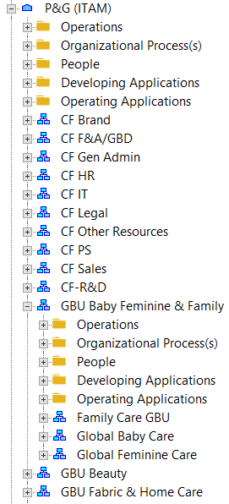

Figure 2: Example of leader assigned to the organization, where Thomas Fielder is the Service Manager of the PTW – Planning Complex Assignment organization.

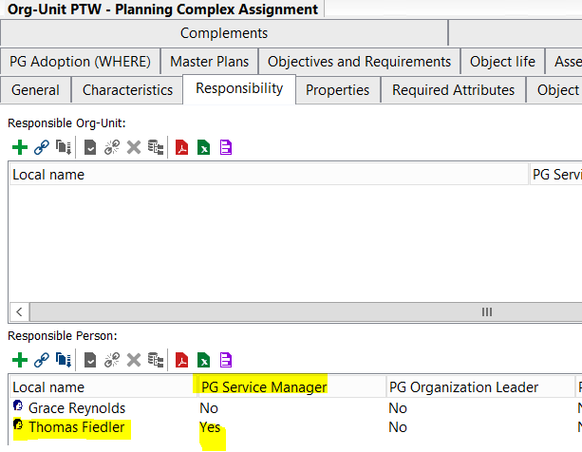

* 1. **OBJECTIVE**

To assign IT assets to an owning organization based from the P&G’s organization hierarchy

In a way that

* The owning organization is reported at multiple levels until the recognized highest organization within P&G, usually at the President or VP level
* That owning organization hierarchy, along with its corresponding owners, comes from MEGA and is synced with RITA daily
* The owning organization hierarchy is composed of 3 levels

So that organizational accountability for the stewardship of the IT asset is recognized

1. **REQUIREMENTS**
   1. **BUSINESS REQUIREMENTS**

|  |  |  |
| --- | --- | --- |
| # | Description | Priority (H, M, L) |
| B001 | Owning organization data in RITA aggregates until the President/VP level | H |
| B002 | Organization leaders should be able to view the apps in their org, or in the sub-organizations under their org. | H |

* 1. **TECHNICAL REQUIREMENTS**

|  |  |  |
| --- | --- | --- |
| # | Description | Priority (H, M, L) |
| T001 | The organization hierarchy data is imported as a csv file from MEGA through Boomi | H |
| T002 | The organization hierarchy data is imported through the same existing process between Boomi and RITA | H |
| T003 | The organization hierarchy csv file (*name is pending*) will be in the same blob folders as the other MEGA csv files | M |
| T004 | The organization hierarchy csv file is composed of 18 columns:   * Level 1 Organization Hex ID * Level 1 Organization Name * Level 1 Organization Leader Hex ID * Level 1 Organization Leader Name * Level 1 Organization Intranet Name * Level 1 Organization T-number * Level 2 Organization Hex ID * Level 2 Organization Name * Level 2 Organization Leader Hex ID * Level 2 Organization Leader Name * Level 2 Organization Intranet Name * Level 2 Organization T-number * Level 3 Organization Hex ID * Level 3 Organization Name * Level 3 Organization Leader Hex ID * Level 3 Organization Leader Name * Level 3 Organization Intranet Name * Level 3 Organization T-number | H |
| T005 | The Application Governance report under the RITA – Asset Gov Overall workspace (and all other workspaces where this report is available) is updated to include the following columns:   * Owning Org (MEGA) * Org Leader * Level 2 Org Name * Level 2 Org Leader * Level 1 Org Name * Level 1 Org Leader   These columns should be in between the Org Name column and before the Last Reviewed Date columns | H |
| T006 | The Org Name column is renamed to Employee Org (LDAP). | M |
| T007 | Calculations for the new fields are as follows:  Owning Org (MEGA) – this can be obtained from the PGV_APP_RESPONSIBLE_ORG_RITA staging table (or the corresponding dimension table), by looking up the application via HexID and getting the distinct record where value in the PG Development Org field = ‘Y’. If that record is available, then the Owning Org (MEGA) value will come from the Responsible Org Unit column.  Org Leader – based on the Owning Org (MEGA) value (or hex ID) of the application, look it up the org hierarchy table on the Level 3 Organization (Name/Hex ID) and return the Level 3 Organization Leader Name. If the Owning Org can’t be found in Level 3, then look it up on the Level 2 Organization and return the Level 2 Organization Leader Name. If the Owning Org can’t be found in Level 2, then look it up on the Level 1 Organization and return the Level 1 Organization Leader Name. If the Owning Org can’t be found in Level 1, then leave the field as blank.  Level 2 Org Name – based on the Owning Org (MEGA) value of the application, look it up the org hierarchy table on the Level 3 Organization (Name/Hex ID) and return the Level 2 Organization Name. If the Owning Org can’t be found in Level 3, then look it up on the Level 2 Organization and return the Level 2 Organization Name. If the Owning Org can’t be found in Level 2, then leave the field as blank.  Level 2 Org Leader – use the same logic as the Level 2 Org Name, but return the Level 2 Organization Leader Name instead of the Level 2 Organization Name.  Level 1 Org Name – based on the Owning Org (MEGA) value of the application, look it up the org hierarchy table on the Level 3 Organization (Name/Hex ID) and return the Level 1 Organization Name. If the Owning Org can’t be found in Level 3, then look it up on the Level 2 Organization and return the Level 1 Organization Name. If the Owning Org can’t be found in Level 2, then look it up on the Level 1 Organization and return the Level 1 Organization Name. If the Owning Org can’t be found in Level 1, then leave the field as blank.  Level 1 Org Leader – use the same logic as the Level 1 Org Name, but return the Level 1 Organization Leader Name instead of the Level 1 Organization Name. | H |
| T007 | Owning Organization slicer should be added in the report. This contains the hierarchy from the new csv file. It should only contain the Level 1 Org Name, Level 2 Org Name and Level 3 Org Name in a hierarchy format.  Ex.  IT Solutions  IT ITS – Gov & Agile Trans  ITS – Design, Asset and Risk |  |

* 1. **SECURITY REQUIREMENTS**

|  |  |  |
| --- | --- | --- |
| # | Description | Priority (H, M, L) |
| S001 | Organization leader, based on Org Leader column, should be able to view all apps in his/her org and all applications in sub-organizations under his/her org.  Use the org hierarchy file to determine the sub-organizations. | H |
| S002 | Admin users should be able to view apps with no organizations/org leaders | H |

* 1. **NON-FUNCTIONAL REQUIREMENTS**

|  |  |  |
| --- | --- | --- |
| # | Description | Priority (H, M, L) |
| F001 | Performance of the report should not be negatively impacted due to S001. Page should still be quick to load for the org leader. | H |
| F002 | Performance of the report should not be negatively impacted due to the 6 new fields added in the report. Page should still be quick to load for the user. | H |

1. **DEPENDENCIES**

|  |  |  |
| --- | --- | --- |
| # | Description | Priority (H, M, L) |
| D001 | The existing Boomi integration with RITA includes the org hierarchy data | M |
| D002 | The MEGA DB view containing the org hierarchy data is available | H |

1. **ASSUMPTIONS**

|  |  |
| --- | --- |
| # | Description |
| A001 | The hardware asset to owning organization relationship will only be available by JFM19 |
| A002 | The organization hierarchy is properly maintained in MEGA |